**CEN100 - INTRO TO ENGINEERING**

**DISASTER PROJECT - FINAL RESEARCH PAPER**

**Due Date:** Nov 3rd, 2021 at 3PM

**Project Title:** The Quebec Bridge Collapse

**Student Section:** 29

**GA and PM Name:** Shereen Al Tamimi and Suhasse Patel

| Member: | Student Number | Signature |
| --- | --- | --- |
| Tejveer Goga | 501088306 |  |
| Joaquin Kataoka | 501104688 |  |
| Adrian Parungao | 501102077 |  |
| Bilal Asghar | 501113295 |  |
| Hamza Malik | 501112545 |  |

*By signing the above you attest that you have contributed to this submission and confirm that all work you contributed to this submission is your own work. Any suspicion of copying or plagiarism in this work will result in an investigation of Academic Misconduct and may result in a ”0” on the work, and “F” in the course, or possibly more severe penalties, as well as a Disciplinary Notice on your academic record under the Student Code of Academic Conduct, which can be found online at [www.ryerson.ca/academicintegrity/students/ryersons-academic-integrity-policy-policy-60/](https://www.ryerson.ca/academicintegrity/students/ryersons-academic-integrity-policy-policy-60/)

# ABSTRACT

The Quebec Bridge disaster is one of the most impactful historical disasters in Canadian history.

The overall objective of this report is to inform the public about the tragic collapse of the Quebec Bridge in 1907. It investigates who caused the collapse, what caused the collapse, when did the collapse occur, where did the collapse occur, why did the collapse occur, and how was the collapse caused. A brief summary of this is described under the introduction heading of the research paper. Also, the introduction gives in depth background knowledge about everything leading up to the collapse, so the audience can obtain a deeper understanding of the problem. Then,the analysis and investigation, covers the causes, impacts, and ethics and professionalism of the collapse. It extensively looks at the major factors that caused the collapse such as financial straits and poor execution. Then it looks at who exactly, and what exactly the collapse impacted both financially and emotionally and the unethical and unprofessional aspect causing the collapse. Next, the recommendations are covered. Under this heading, possible recommendations to prevent the errors leading to the collapse are covered. Also, recommendations are made to prevent such a disaster from happening again. Finally, the conclusion gives an overall summary of the information, along with its relevance to the topic.

# **I**NTRODUCTION AND BACKGROUND

The Quebec Bridge disaster was the collapse of the bridge on August 11,1907 in Quebec City along the St.Lawrence river due to several factors such as poor execution of the procedure, limited financial availability, and constant errors in important calculations. This disaster was chosen to research because of how impactful it was. Understanding that at the time being, the bridge was not only set to break world records of both length and cantevilar spans but, Quebec city was set to become a competitor in the trade world. The St.Lawrence river was the key asset, but because the St.Lawrence would freeze in the winter time, the city thought it would be a great idea to create a transport network to have zero limitations with trade. This disaster was important because of how severely it impacted families across Canada. At the time being, workers were leaving their families to come work for years on end to support their families, and to see some of the workers die because of the incident is tragic. Also, this disaster is important because it can help future engineers look at the mistakes of the Quebec Bridge collapse. From this study, the causes, impacts, ethics and recommendations can be learned. The reader, more specifically engineers can look at the causes of the collapse, who exactly and what exactly it impacted and what could be done to prevent such a disaster from occurring.

Interest in constructing the bridge began in 1850, but the idea finally began its momentum almost 37 years after in 1887. This happened when a group of politicians and businessmen formed the Quebec Bridge Committee. Now, due to such high levels of interest in the project, the Quebec Bridge Committee passed the Canadian act, therefore incorporating the company with $1 million capital. The biggest challenge of the company was financing the bridge. Funding was requested by the government, however the government could not provide funding until a location for the bridge was selected. Then, in 1898, after several years of disagreement, the Chaudiere site was selected through preliminary surveys made by the local Quebec legislature. The majority of the members of the Quebec bridge company were inexperienced. The chief engineer, Edward Hoare had never worked on a bridge longer than 90 feet, which led to the hiring of Theodore Cooper, A consulting engineer, with strong, convincing qualifications for the project. The Phoenix Bridge Company had been working with Cooper throughout the lead up to the construction. Two months later, the Quebec Bridge Company offered contracts to the Phoenix Bridge Company, but they instantly refused to sign due to the lack of financial resources. Financial matters were resolved in 1903, after funding was provided through a government grant, after the company began its construction. The dimensions of the bridge were constantly changed by the company. Theodore Cooper expanded the length from 487.7 m to 548.6 m. This was believed to be done because Cooper wanted the title of constructing the longest bridge in the world, at the time being. Construction of the bridge officially began on October 2,1900.

The Quebec Bridge first collapsed in 1907, due to the poor construction of the lattice chords. This was done due to lack of financial support and resources, along with the poor execution of the construction. The bridge collapsed at approximately 5:30 p.m. The loud collapse of the bridge was heard several kilometers away in Quebec. The entire southern half of the bridge, approximately 189 MN of steel, went crashing into the St.Lawrence river in less than 15.0 seconds. Of the eighty workers present at the scene, only eleven of them survived the collapse. The Government General of Canada created a Royal Commission, which was a group of three civil engineers who were responsible for investigating the cause of the collapse. They stated several points that caused the bridge to collapse, but the major reason was due to the buckling of cords A9L and A9R. The official report by the Royal Commission also stated that the bridge collapsed for the following reasons: Failure of the chords in the lower arm were resulted from defect in design, assuming such a low value for the dead load for the calculations was said to be of sufficient magnitude, but most importantly, they pointed out that assigning the role of the chief engineer to an experienced bridge engineer (Cooper) was a big mistake.

After the collapse, the government took charge and control of the construction of the bridge. This also provided substantial financial support for the project. The second attempt of building the bridge also encountered several problems. The project suffered another collapse in 1916, when the center suspended span fell into the water after a casting on the lifting apparatus broke off. Thirteen workers were lost due to this incident. The 50MN span of steel sank to the bottom of the river along with the wreckage from the first collapse, which, till this day remains there. The second bridge was finally completed in 1917.

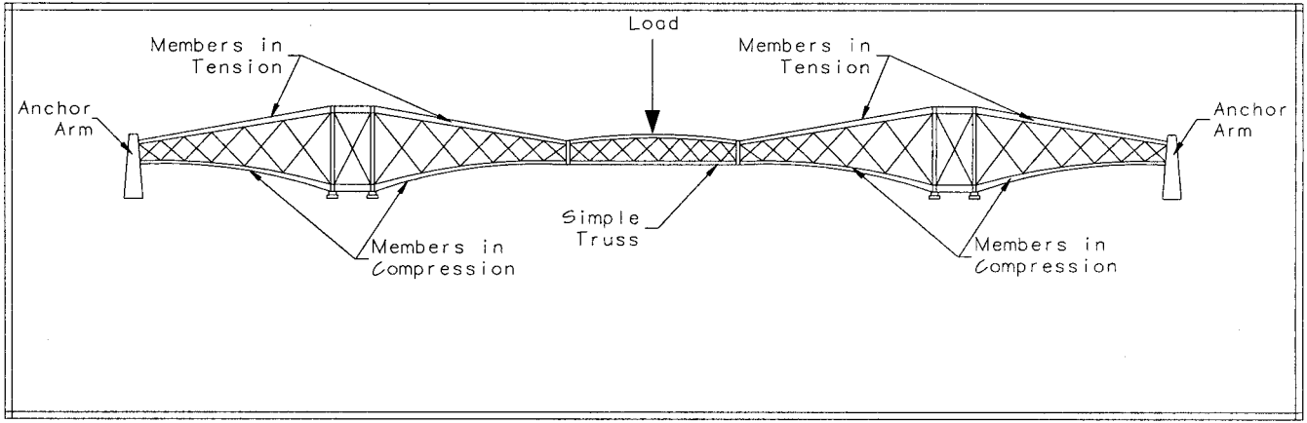

**Fig. 1.** Structural behavior of cantilever bridge

Source: Adapted from [1]

# ANALYSIS AND INVESTIGATION

## **CAUSES**

Several factors contributed to the catastrophic failures of the two Quebec bridges, from flaws in design to grave errors in miscalculations. The following will provide a deeper interpretation of these causes. From the beginning, the Quebec bridge project was in financial straits, which resulted in several issues throughout the design process and construction phases. Primarily, of all causes, one which led to the first collapse was the inaccurate lattice design on the compression chords. Due to its defective design, the deflection in the chords increased, causing a major Member Chord A9L to buckle on the anchor arm triggering the fall. This is shown in figure 2 below where the major deflection in Chord A9L had occurred, and in table 1 which goes into more depth of the bridge members that were observed with their noted deflections.

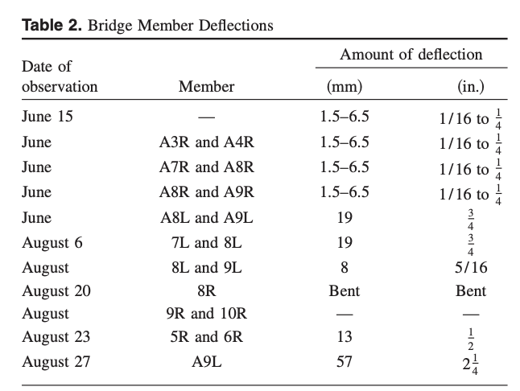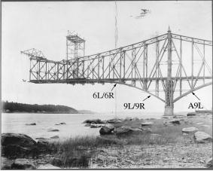

| **Fig. 2.** Quebec bridge just before the collapse | **Table. 1.** Bridge members with the amount of deflection observed. |
| --- | --- |

Source: Adapted from [1] Source: Adapted from [1]

One factor which hastened the disaster was the stresses not being recalculated when the bridge spans were increased from 487.7 m to 548.6 m. When this error was discovered, a large portion of the project was already completed. The new load and stresses for the bridge were determined right away and the difference in percentage concluded from the results were massive. The initial design of the Quebec bridge weighed 276 MN, whereas the actual weighed 325 MN. Table 2 below goes into more depth with the percentage differences between the elements assumed and actual dead loads of the structure.

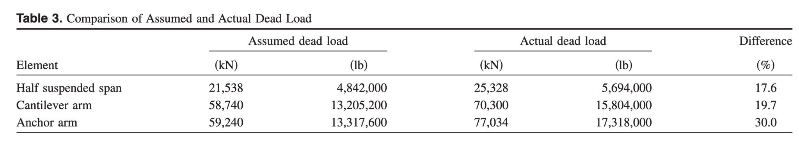

**Table. 2.** Comparison between the assumed and actual dead load.

Source: Adapted from [1]

Piling up onto the previous flaws, the allowable stresses were changed by Cooper from 145 Mpa to 165 MPa. These stresses were questioned by other bridge engineers but were accepted due to Cooper's distinguished reputation and previous experiences. The equation used by Cooper to calculate for allowable stress is shown below.

Allowable compressive stress

Source: Adapted from [1]

The formula used by Cooper is declared to be unsafe practice due to a lack of understanding of compression members as well as the use of low-quality material.

Another contributing factor to the cause was the significant lack of testing shown by Cooper. Critical components like the eyebars and compression members testing were not conducted due to lack of funds and Cooper's misinterpretation of theories, but when funds were made available, Cooper refused to conduct any further testing saying much time had already been wasted.

After the project was taken over by the government from experiencing the first collapse, it, unfortunately, had to deal with a second collapse due to the overall structure of the bridge being much heavier causing the massive 50 MN center load span of the bridge to fall deep and sink into the bottom of the St Lawrence river while being hoisted into place. When both of the two bridges were compared after the disaster, there were substantial differences in the member sizes.

## **IMPACTS**

The bridge’s two collapses had a huge impact on Canadian engineering and helped to further demonstrate the destructive powers engineers hold in their work. The following are a list of lasting impacts the collapses of the Quebec Bridge had, both short-term and long-term.

In terms of the loss of life, 88 workers were killed during the bridge’s entire construction. The first collapse took the lives of 75 workers, while injuring an additional 11. The first collapse also resulted in several tons of metal debris falling into the river below, as shown in Figure 3. The debris reportedly [3] took more than two years to fully clear out.

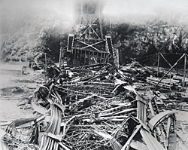

**Fig. 3.** The debris caused by the first collapse

Source: Adapted from [1]

The second collapse resulted in the deaths of 13 workers, bringing the number of casualties to the previously mentioned total of 88. The families of the workers who died were left to mourn their losses, forever changed by the events that transpired during the bridge’s construction. The second collapse of the bridge is visible here in Figure 4.

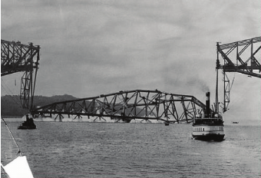

**Fig. 4.** The second collapse of The Quebec Bridge

Source: Adapted from [7]

Following the first collapse of the Quebec Bridge, a Royal Commission was formed to investigate and provide a report regarding the collapse. The engineers were successful in finding the causes regarding the collapse, resulting in a report over 200 pages long. To this day, the report stands as an important case study in forensic engineering for its thoroughness. As author Middleton stated in a review of the collapse, “ …the thoroughness and objectivity of their inquiry and report stand even today as models of their kind” [1]. The report also places much of the blame upon Theodore Cooper. Following the collapse, Cooper’s career was essentially in shambles, and he would quietly retire from his position. Aside from Cooper, Chief Design Engineer Peter L. Szlapka was held responsible for the collapse, coming to the conclusion that “the failure cannot be attributed directly to any cause other than errors in judgment on the part of these two engineers” [2]. Szlapka would continue to work at Phoenix Company until his eventual retirement.

The two collapses of the Quebec Bridge had also led to issues regarding trading routes. As [1] states, the bridge was meant to provide a reliable means of transportation over the St. Lawrence River during the cold winter months where ice would build up . Such a means of transportation would have helped Quebec remain competitive in the trading market. Thus delays caused by the two collapses, as well as the finances lost over the construction of the two failed attempts, led to the loss of large sums of potential revenue.

Despite the bridge’s collapses having occurred more than a century ago, the repercussions of the events that transpired are still felt by Canadians today. Most notably, the Ritual of the Calling of an Engineer was inspired by the collapse of the Quebec Bridge. In 1922, Professor Haultain and Rudyard Kipling created the ritual in response to the bridge’s collapse due to their belief that it was caused by poor management and miscommunications. In the same way doctors had the Hippocratic Oath, they believed engineers needed an oath of a similar fashion, as stated in [6]. Thus, the ceremony and the iron ring tradition was created to remind engineers of their ethics and dignity while in practice. As Al Czarnecki stated in an article published by The Toronto Star, “thousands of Canadian engineers wear a small ring on their little finger to remind them of the 1907 tragedy and the responsibility they bear every day” [5]. In addition, the bridge was declared a national historic site in 1995 in celebration of it being the world’s longest clear-span cantilever bridge, as well as to honour those who lost their lives during the bridge’s construction. When the bridge was finally completed in 1919, the result was a bridge that was much larger and heavier than anticipated, but completed nonetheless (as seen in Figure 4).

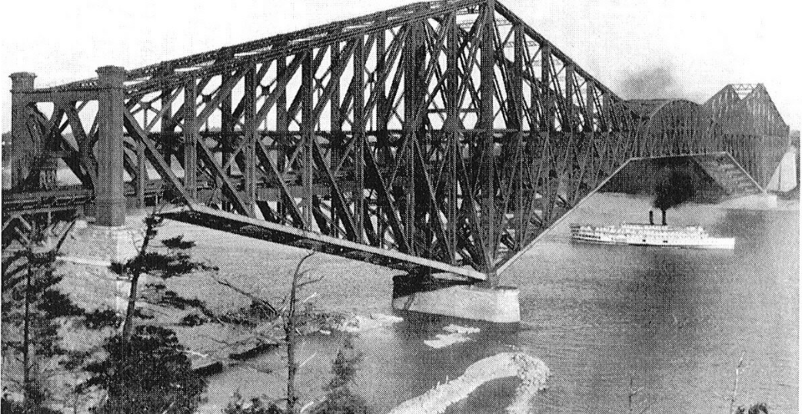

**Fig. 5.** The rebuilt and completed Quebec Bridge

Source: Adapted from [2]

# 

# ETHICS AND PROFESSIONALISM

The ethics and the professionalism of the parties involved in the design of the bridge can be pointed out as factors that led to the collapse in 1907. The three major parties involved, the “Quebec Bridge and Railway Company”, the “Phoenix Bridge Company”, and the consulting engineer Theordore Cooper all contributed to the ethical and professional concerns involved in the collapse of the bridge.

The “Quebec Bridge and Railway Company” or “QBRC” for short, was the company that managed the Quebec bridge project from 1881 up until the collapse in 1907. In [8] the commission team found that during the development of the bridge the “QBRC” lacked the funds necessary to properly back the project, and in [2] [9] the result of this lack of funds was found to have had an influence on the design process. In [9] an attempt to reduce costs was made by the “QBRC” and they instructed Cooper to consider the company's financial situation when deciding which independent source was to design and build the bridge. This led “Cooper'' to choose the design proposed by the“Phoenix Bridge Company” for being the “best and cheapest” [2], which stated in [2] was unusual, as large projects at the time were usually contracted out to independent engineering firms. Another example of the company prioritizing costs is in [2] when Edward Hoare the chief engineer for the “QBRC” was not given a proper guideline for the specifications as the company did not spend money on creating a suitable guideline. Hoare had to create the specifications using “the 1896 specifications of the Department of Railways and Canals for routine steel and iron bridges” [2] which were said to not be suitable for larger projects such as the one at hand. As a result stated in [2] the effects of the improper guidelines were increased when Cooper tried to amend the specifications but inadvertently increased the allowable stress on the rivets, as they were set to be ratio of the maximum stress of the chords.

The “Phoenix Bridge Company” (PBC) and their chief designer Peter Szlapka was another party involved in the development of the bridge. The major ethical and professional concerns of the “PBC” arose during the construction of the bridge when the deformations in the compression members were starting to show. In [1] it is stated that actions regarding the deformations in the members were delayed due to arguments between the on-site engineers. This is an ethical concern however, the one that specifically regards the “PBC” is stated in [9] that Szlapka allowed the “PBC” to claim that the compression members that were deformed from stress had actually arrived deformed. This was both an ethical and professional concern towards the value of proper engineering principles. Another concern over the professionalism of the “PBC” was during the estimation of the total supportable weight of the bridge. In [2] the “PBC” has segmented the design process of the bridge to increase workflow efficiency, however this made a correct weight estimate impossible as this would require the entire design to be completed before any correct calculations could have been made. The design process of the “PBC” was modified for this project to increase efficiency as the company would have been charged for any extra time they took in the drafting of the bridge. In [2] the “PBC” had ignored the first principle of design and instead cut corners and used upscaled previous chord designs from older bridges as the basis of the design. The result was an overall thinner chord design especially when compared to the redesigned chords of the 1917 Quebec bridge as seen in figure 6.

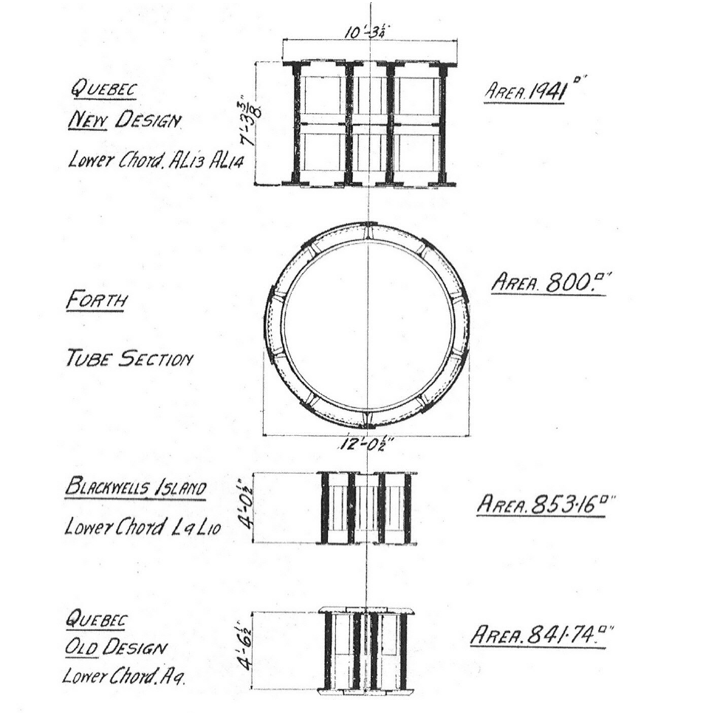

**Fig. 6.** A comparison of the “New Quebec”, “Firth of Forth”, “Blackwell's Island” and

“Old Quebec” bridge chord designs.

Source: Adapted from: [2]

The final party involved was the consulting office of Theodore Cooper who was the primary engineer to oversee the entire development of the bridge. Cooper was also the source of several ethical and or professional concerns. Stated in [1], during the development of the bridge Cooper refused to have any independent engineer or source review the design of the bridge and even in [9] “he demanded full technical control and blocked an attempt by the chief engineer of the Canadian Department of Railways and Canals to have drawings independently reviewed in 1903”. This was both an ethical and professional concern as this meant most of the design process relied on only Cooper’s engineering knowledge. In [2] Cooper was said to have believed that manufacturing companies such as the “PBC” should be able to freely create the initial design of the bridge however, as stated later in [2] use of this method put a lot of pressure on the draftsmen at the “PBC”. Once again stated in [2] Cooper’s ideals were different from the common professional opinion. In [9] during the construction of the bridge Cooper had “regarded on-site visits as unproductive” [9] and such his last visit to the site was in May of 1903 [9]. Since Cooper was no longer visiting the site this left only Norman McLure the inspector for Cooper and Hoare as the on-site engineers however, in [9] Mclure lacked the authority to take action against the deformations in the compression members and Hoare “held a position for which he did not have the technical competence” [9]. It was from the lack of experience of the onsite engineers and Cooper’s negligence that work resumed on the bridge that was ready to collapse. The final concern over Cooper’s professionalism was his decision to become the consulting engineer for the project. In [2] Cooper knew that the given time frame of 3 years was not enough to successfully complete the project, Cooper even stating:

“As I understand it, the time seated in this contract for the completion of the work, as verbally given me by Mr. Deans at the time, is three years. I protested against that, and stated it was an absolute impossibility to construct that bridge in three years, that under the most favourable circumstances without considering any contingencies, four years at least would be needed, and five at least should have been asked for” [2]

Cooper also knew of the financial restraints of the “QBRC” that he would have to abide by during the project, stating in [8] “during the early progress of the work it was an open secret that the Quebec Bridge Company had but a small amount of money in sight”. Knowing that the time frame given was too short and that the head company was short of funds Cooper still opted to be the consulting engineer for the entire project.

# RECOMMENDATIONS

In engineering, even the smallest miscalculations can lead to a disaster, which is what happened during the first collapse of the Quebec Bridge. When the bridge spans were increased from 487.7 m to 548.6 m, the stresses should have been recalculated. In order to prevent a disaster like this from happening again, calculations should be done multiple times and by different people, so that errors can be reduced and any miscalculations can be reevaluated.

Any engineering project should be audited based on a standard for that project, in order to confirm that the project conforms with standards. These standards are guidelines and procedures prepared by organizations/companies or ISO (International Standard Organization) or CSA (Canadian Standard Association), which are supposed to be followed during the design, manufacturing, testing and other processes. They make sure that the quality of the project is assured/controlled.

The cornerstone of a successful engineering project lies within a responsible and active leader. Chief Engineer Theodore Cooper (See Figure 5) failed to be a proficient leader through his lack of presence and engagement with his team and the project. To stop catastrophes like this from occurring, it is essential to have a Chief Engineer who is both willing and capable to be present at the site of construction to allow for proper and efficient communication. Furthermore, having an experienced engineer lead the project is just as important. This was Cooper’s first time being the chief engineer of a major project and that heavily impacted the quality of construction.

In the field of engineering it is prudent that there is a high level of professionalism maintained in every aspect of the job, especially when designing projects that can involve the health and safety of the people. It is this high level of professionalism and dignity that keeps people safe, and it is when this standard is lowered that accidents and tragedies occur. In the case of the Quebec bridge collapse it seems that one of the major factors that contributed to the collapse was the limiting factor of time and money of the “QBRC”. For the duration of the project it seemed that all parties involved prioritized finance and efficiency over the greater design of the project, and it was because of this reduction in standards that the flaws in every party were enhanced. Although time and money should be considered for the design of a project it is important that the quality of the design should always come first.

# CONCLUSION

To conclude, the Quebec Bridge collapses were terrifying engineering disasters which had occurred twice resulting in 88 deaths and 11 injuries. After the first collapse occurred, the main reasons were due to defective design which caused a Chord A9L to buckle, triggering the fall. For the second collapse, the bridge was much heavier, resulting in a second collapse when the center load span of the bridge fell into the St. Lawrence river. The collapses proved to be catastrophic, having both short-term and long-term impacts on Canadian engineering as a whole. As the bridge was a cruel reminder as to the destructive capabilities engineers hold in their work, a ceremony was established to remind engineers of the horrific events that took place in 1907. The ethics and professionalism displayed were also questionable, with many reckless and irresponsible decisions being made by both Theodore Cooper and Peter L. Szlapka. Both engineers had mandated inexcusably high stresses and showed incompetence in their ability to lead and communicate with their team. Thus, the Quebec Bridge stands as a monument in Canadian history today; an important lesson in engineering and the ramifications of unsafe practice.

# ACKNOWLEDGEMENTS

The completion of this research paper would not have been possible without the efforts of many individuals. This includes all members of our disaster research project group, our project manager, graduate assistant, as well as the librarian. The members of our research project group include Hamza Malik, Tejveer Goga, Joaquin Kataoka, Adrian Parungao, and Bilal Asghar. The project manager helped guide us through the layout structure of our paper and other critical components to make it more logical. The librarian guided us through citations for IEEE formatting. With her efforts, we were able to get a better understanding on how the citations would have to be done.

# BREAKDOWN OF DUTIES AND RESPONSIBILITIES

# In order to efficiently, effectively and without overloading the team members complete this project, it was broken down into separate responsibilities and duties for each team member. The First half of the project included a Team Contract and a Project Task Outline, an Extended Abstract, and a Presentation.

# 

Responsibilities for First half of Project:

| **Responsibility** | **Team Member** |
| --- | --- |
| Team Contract | All Members |
| Project Task Outline | All Members |
| Extended Abstract | Bilal |
| Presentation | Adrian and Tejveer |

# The Second half of the project included the Research Paper. The research paper had several parts, so it was divided up between team members.

# 

Responsibilities for Research paper:

| **Part** | **Team Member Responsible** |
| --- | --- |
| Abstract | Bilal |
| Introduction and Background Information | Bilal |
| Causes of the Disaster | Hamza |
| Impacts of the Disaster | Adrian |
| Ethics and Professionalism | Joaquin |
| Recommendations | Everyone |
| Conclusion | Hamza & Adrian |
| References | Hamza |
| Acknowledgements | Hamza & Tejveer |
| Breakdown of duties and Responsibilities | Tejveer |

# The team worked together very well. Team Members communicated through multiple platforms like Discord, Zoom and WhatsApp. Meetings were held on significant dates based on the Project Task Outline and whenever else needed. Any issues were overcome through group-based problem solving.

# REFERENCES

[1] C. Pearson and N. Delatte, "Collapse of the Quebec Bridge, 1907," Journal of Performance of Constructed Facilities, vol. 20, (1), pp. 84-91, 2006. Available: <https://ascelibrary-org.ezproxy.lib.ryerson.ca/doi/full/10.1061/%28ASCE%290887-3828%282006%2920%3A1%2884%29>

[2] E. Kranakis, "Fixing the Blame: Organizational Culture and the Quebec Bridge Collapse," Technology and Culture, vol. 45, (3), pp. 487-518, 2004. Available: <http://ezproxy.lib.ryerson.ca/login?url=https://www.proquest.com/scholarly-journals/fixing-blame-organizational-culture-quebec-bridge/docview/198517631/se-2?accountid=13631>

[3] J. H. Marsh, "'Cheapest plan' for Quebec Bridge: [Final Edition]," Daily Townsman, pp. 5, 2003. Available: <http://ezproxy.lib.ryerson.ca/login?url=https://www.proquest.com/newspapers/cheapest-plan-quebec-bridge/docview/356301891/se-2?accountid=13631>.

[4] Anonymous "ON COLD IRON: A STORY OF HUBRIS AND THE 1907 QUEBEC BRIDGE COLLAPSE," *Kirkus Reviews,* 2020. Available: <http://ezproxy.lib.ryerson.ca/login?url=https://www.proquest.com/trade-journals/on-cold-iron/docview/2407526416/se-2?accountid=13631>.

[5] Anonymous "THE QUEBEC BRIDGE COLLAPSE," The Globe (1844-1936), pp. 6, 1907. Available: <http://ezproxy.lib.ryerson.ca/login?url=https://www.proquest.com/historical-newspapers/quebec-bridge-collapse/docview/1354398677/se-2?accountid=13631>.

[6] Anonymous "Engineers remember Quebec Bridge tragedy: [ONT Edition]," Toronto Star, pp. AA7, 2007. Available: <http://ezproxy.lib.ryerson.ca/login?url=https://www.proquest.com/newspapers/engineers-remember-quebec-bridge-tragedy/docview/439268692/se-2?accountid=13631>.

[7]Biezma, María Victoria, and Frank Schanack. “Collapse of Steel Bridges.” *Journal of Performance of Constructed Facilities*, pp. 398–405, vol. 21, no. 5, 2007. Available <https://doi.org/10.1061/(ASCE)0887-3828(2007)21:5(398)>

[8] P. Home-Douglas, "DON'T CALL IT A Celebration," ASEE Prism, vol. 29, (4), pp. 30-33, 2019. Available: <http://ezproxy.lib.ryerson.ca/login?url=https://www.proquest.com/scholarly-journals/dont-call-celebration/docview/2329717482/se-2?accountid=13631>.

[9 ] H. Holgate et al, Royal Commission Quebec Bridge Inquiry Report also Report on Design of Quebec Bridge: By C. C. Schneider. Printed by Order of Parliament. 1908. [Online]. Available: <https://publications.gc.ca/site/eng/9.827964/publication.html#shr-pg0>

[10 ] W. M. K. Roddis, "Structural Failures and Engineering Ethics," Journal of Structural Engineering (New York, N.Y.), vol. 119, (5), pp. 1539-1555, 1993. [Online]. Available: <https://ascelibrary-org.ezproxy.lib.ryerson.ca/doi/abs/10.1061/(ASCE)0733-9445(1993)119:5(1539)>